**Tiffany Trusty**

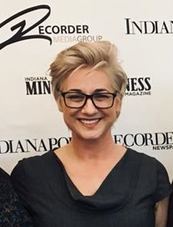

I’m Tiffany Trusty, your typical #NerdyGirl. When I’m not using my Nerd Superpowers for the betterment of my community, I’m standing up to represent diversity in STEM. I started my career in public safety, where I discovered my passion for the customer. It was an honor to serve firefighters and police officers with my products for over 15 years. Now, I serve the patient as my customer. As a Product Manager for a pharma company, my job is finding the right digital product to help the patient manage their conditions and live a better life. When I’m not focused on my customers, I’m focused on supporting the females around me. Being a girl / woman in STEM can be lonely, and I have a lot of karma to pay back to those who paved the way for me. I work with both local and national organizations to make certain those girls with STEM aspirations KEEP GOING and those women in STEM careers feel seen, heard, and supported.

Tiffany Trusty was recruited to Eli Lilly in 2017 to lend her 20 years of software product development expertise to their forthcoming Digital Health organization. At Lilly, she has grown her expertise to include Software as a Medical Device (SaMD), specifically patient facing mobile and web applications. Tiffany began her career at Motorola where she learned the software development lifecycle (SDLC) craft. Experiencing everything from estimation and architecture to coding and testing, Tiffany left Motorola as a Senior Architect with expertise in Design for Testability and Cybersecurity.

Tiffany earned her bachelor's degree in Electrical Engineering from Rose-Hulman Institute of Technology (the 2nd woman to graduate from the previously all-male, #1 in its class institution). After a decade in the industry, she returned to Rose-Hulman to obtain her master's degree in Engineering Management. Tiffany is a proud wife to a fellow engineer and entrepreneur and a proud mother to a confident and caring little girl. She enjoys wine and golf (but not at the same time).